DATA7703 Assignment 1

2022 Semester 2

### Question 1

1. In this question, I took “BODY MASS” as the independent variable and “SVL” as the dependent variable, which I also indicate them as the horizontal and vertical coordinate labels in question (d).

Equation: $SVL=0.05873624*BODY MASS+64.0456745$

SSE: 29081.74531785096

1. Quadratic regression is an extension of simple linear regression. While linear regression can be performed with as few as two points, quadratic regression come with the disadvantage that it requires more data points to be certain your data falls into the “U” shape which will be more visually illustrated in the picture in question (d).

Equation: $SVL= -3.32117126e^{-5}*{BODY MASS}^{2}+9.89928002e^{-2}*BODY MASS+55.314286366833336$

SSE: 23805.339913386662

We can conclude that the error of this model is significantly less than the first one.

1. After substituting the missing values with mean values, the equation and SSE are as follows:

Equation: $SVL=0.05756542*BODY MASS+64.58082298$

SSE: 45598.581262117805

We spotted that the SSE of this model is larger than that of the model before, possibly because the sample distribution was changed by mean imputation, leading to great differences in results.

1. The imputed data and models from (a), (b), (c) plot is shown as follows:

### Question 2

**Python Code:**

import pandas as pd

import numpy as np

from sklearn.preprocessing import PolynomialFeatures

from sklearn.linear_model import LinearRegression

df2 = pd.read_csv('reg2d.csv', header=None).values

X2 = df2[:,0:2]

y2 = df2[:,2]

quadratic_featurizer2 = PolynomialFeatures(degree=2, include_bias=False)

X2_quadratic = quadratic_featurizer2.fit_transform(X2)

reg_quadratic2 = LinearRegression().fit(X2_quadratic, y2)

print("Linear model's coefficient values of Question 2: ", reg_quadratic2.coef_,"Intercept:" , reg_quadratic2.intercept_)

**Results:**



### Question 3

1. In this sub-question, I am using the sample mean of the values for a given column and substitute this for the missing values.

Python code:

import pandas as pd

import numpy as np

df3 = pd.read_csv('penguins_size.csv')

mass_average = np.mean(df3['body_mass_g'])

length_average = np.mean(df3['flipper_length_mm'])

df3.loc[:,'body_mass_g'] = df3['body_mass_g'].fillna(mass_average)

df3.loc[:,'flipper_length_mm'] = df3['flipper_length_mm'].fillna(length_average)

df3.head()

Result:

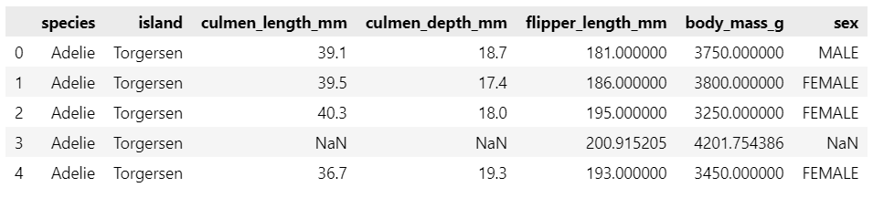

We can clearly see that in row “3”, "culmen_length_mm", "culmen_depth_mm" and "sex" are still “Nah”, while the NaH values for "flipper_length_mm" and "body_mass_g" have been completed.

1. Python Code:

import matplotlib.pyplot as plt

plt.scatter(df3[df3['species']=='Adelie']['body_mass_g'], df3[df3['species']=='Adelie']['flipper_length_mm'], label='Adelie')

plt.scatter(df3[df3['species']=='Chinstrap']['body_mass_g'], df3[df3['species']=='Chinstrap']['flipper_length_mm'], label='Chinstrap')

plt.scatter(df3[df3['species']=='Gentoo']['body_mass_g'], df3[df3['species']=='Gentoo']['flipper_length_mm'], label='Gentoo')

plt.title("Question 3 (b)")

plt.xlabel('body_mass_g')

plt.ylabel('flipper_length_mm')

plt.legend()

**Result:**

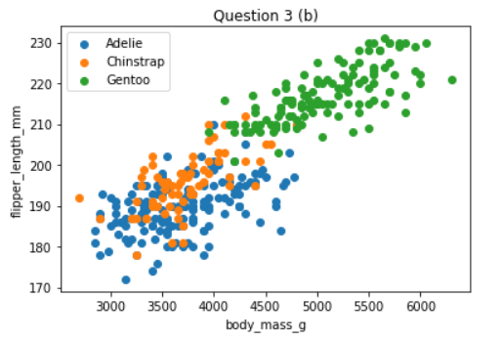

1. Python Code:

from sklearn.model_selection import train_test_split

X3 = df3.iloc[:,4:6]

y3 = df3.iloc[:,0]

X_train, X_test, y_train, y_test = train_test_split(X3, y3, test_size=0.30, random_state=617)

print(X3.shape, X_train.shape, X_test.shape)

print(y3.shape, y_train.shape, y_test.shape)

Result:

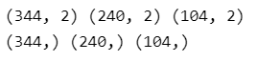

Since we have 344 rows of data and 344*0.7≈240.8, we should have 240 rows of data for X_train & y_train, while 344-240 = 104 rows of data for X_test & y_test, as shown in the output.

1. Python Code:

from sklearn.preprocessing import StandardScaler

from sklearn.neighbors import KNeighborsClassifier

scaler = StandardScaler()

scaler.fit(X_train)

*# Perform standardization by centering and scaling*

X_train = scaler.transform(X_train)

X_test = scaler.transform(X_test)

train_error = []

test_error = []

*# Calculating error for K values between 1 and 21*

for i in range(1, 21):

knn = KNeighborsClassifier(n_neighbors=i)

knn.fit(X_train, y_train)

pred_i_train = knn.predict(X_train)

train_error.append(np.mean(pred_i_train != y_train))

pred_i_test = knn.predict(X_test)

test_error.append(np.mean(pred_i_test != y_test))

plt.figure(figsize=(12, 6))

plt.plot(range(1, 21), train_error, color='red', marker='o', markersize=5, label='Error Rates for Different K in the Training Set')

plt.plot(range(1, 21), test_error, color='blue', marker='o', markersize=5, label='Error Rates for Different K in the Test Set')

plt.title('Question 3 (d)')

plt.xlabel('K Value')

plt.ylabel('Mean Error')

plt.legend()

Result:

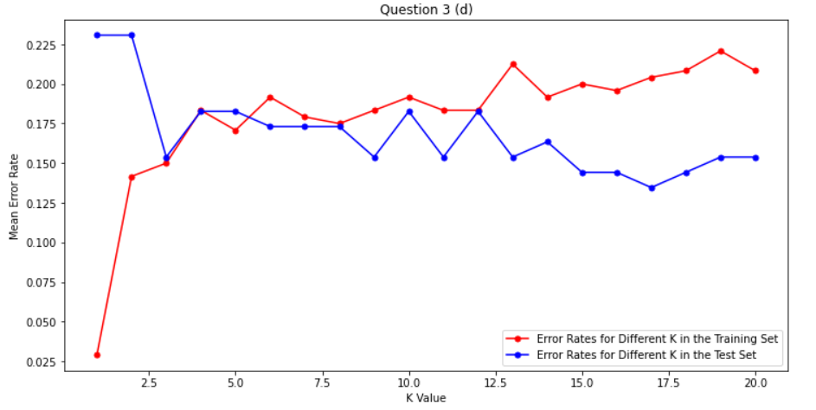

1. Python Code:

from sklearn import tree

from sklearn.metrics import accuracy_score

tree_model = tree.DecisionTreeClassifier(criterion='gini')

tree_model.fit(X_train, y_train)

Ypred_tree_train = tree_model.predict(X_train)

Ypred_tree_test = tree_model.predict(X_test)

tree.plot_tree(tree_model)

print("The training set errors rate is: " , 1 - accuracy_score(Ypred_tree_train, y_train))

print("The test set errors rate is: " , 1 - accuracy_score(Ypred_tree_test, y_test))

Result:

It seems that this decision tree is over-fitting, we cannot even see the criteria for each node clearly, so I modify the code:

“tree_model = tree.DecisionTreeClassifier(criterion='gini', max_depth=2, min_samples_leaf=2)”

in order to make the tree more readable. The result is as follows:

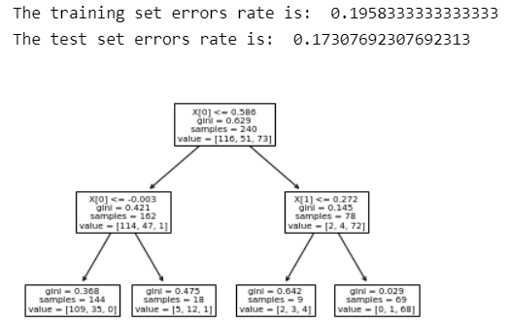

But in fact, this may lead to the under-fitting result. For example, the leftmost Leaf node has 144 samples in total, but obviously it can be subdivided further. Unfortunately, I am not able to solve this problem at present.